WORLD WIDE WEB (WWW)
Tasks
1.Open your browser and visit www.wikipedia.org, then note down the protocol, domain name, and top-level domain you see in the URL bar.

DETAILS | ANSWER
Protocol | HTTPS
Domain name | Wikipedia.org
Top-Level Domain | .org

2.Create a diagram (hand-drawn or digital) that shows how a web browser, web server, and DNS interact when you type www.zomato.com into your browser and press Enter.<br><br><em><strong>Hint:</strong> Include steps like DNS lookup, HTTP request, and server response.</em>

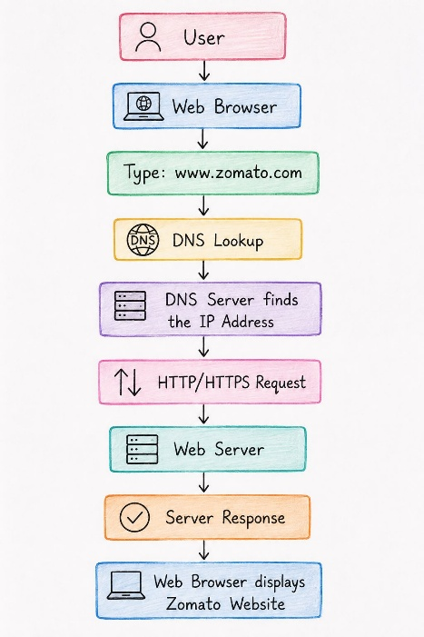

3.List 5 popular websites you use daily (like Instagram, Flipkart, IRCTC, etc.) and identify the type of website each one is (static, dynamic, or web application).

NO | WEBSITE | TYPE
1 | Instagram | Web aaplication
2 | Flipcart | Web aaplication
3 | IRCTC | Web aaplication
4 | Wikipedia | Dynamic website
5 | Amazon | Web aaplication

4.Explain the difference between HTTP and HTTPS by giving a real example of a site you use that shows the padlock icon in the browser.

HTTP | HTTPS
HTTP stands for HyperText Transfer Protocol. | HTTPS stands for HyperText Transfer Protocol Secure.
It does not encrypt data. | It encrypts data using SSL/TSL.
It is less secure. | It is more secure.
Usually uses port 80. | Usually uses port 443.
No padlock is normally shown for a secure HTTPS connection. | A padlock is normally shown in the browser for HTTPS.
- Example : Google is an example of a website that uses HTTPS.

